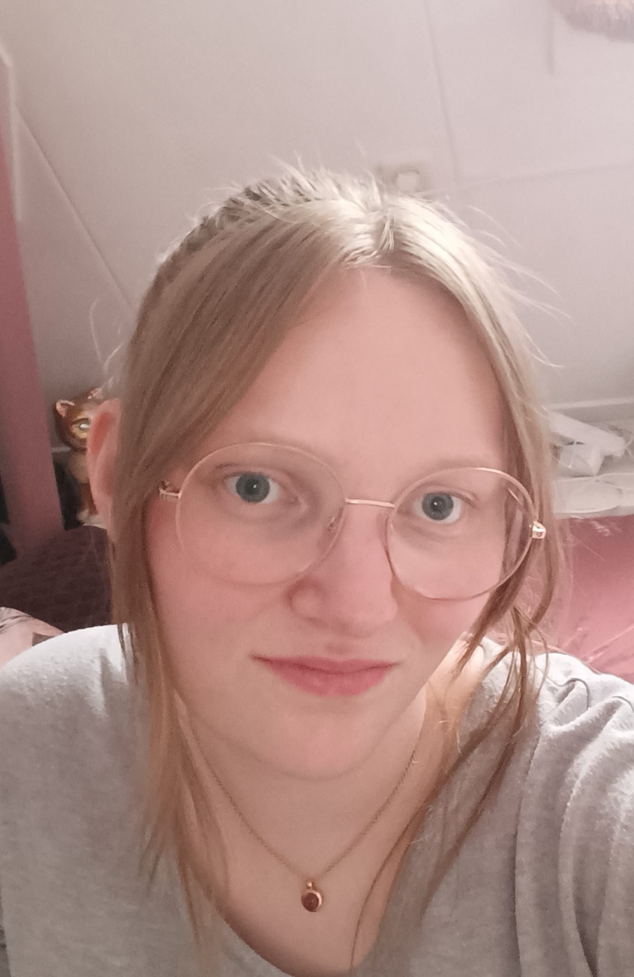 |  |  | Lotte  van Elburg  S3489949  work experience  2019–2024  help • Scholten Fietsgoed •  education  Het Aurum College, Lelystad  - VWO diploma with mathematics B, mathematics D, English, and biology and physics, chemistry, Dutch, economics, and profile paper on mathematics a four-dimensional space.  UNIVERSITY OF TWENTE  - Creative Technology  LOI, from home  - typing course, got diploma with 180 strokes per minute.  skills  - Excellent at handling Microsoft Office.  - Math and logic are my strengths.  hobbies  - Crochet  - Drawing  - Biology  - Physics  - Chemistry  - Mathematics  - Singing  Credentials  Credentials are available on request.
 | Papendwarsstraat 2a  8011 PM Zwolle
 | 0627224881
 | lottievanelburg@gmail.com

don’t
stop
untill
you’re
proud
my life philosophy

